**Version B**

**Semester 2: Practice Hands-on Exam**

***TOPOLOGY:***

L1,L2,L3,L4

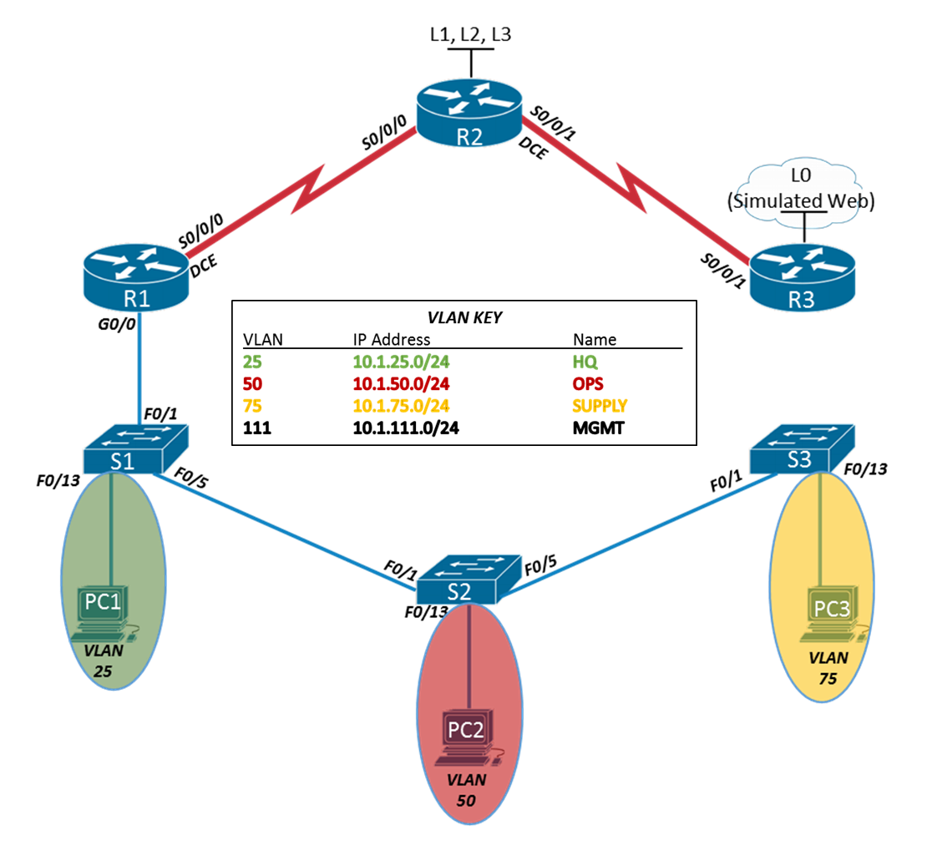

***ADDRESSING TABLE:***

|  |  |  |  |  |
| --- | --- | --- | --- | --- |
| ***Device*** | ***Interface*** | ***IP Address*** | ***Subnet Mask*** | ***Default Gateway*** |
| R1 | S0/0/0 | 172.100.12.1 | 255.255.255.252 | N/A |
|  | S0/0/0 | 2001:ABCD:DCBA:12::1 | /64 | N/A |
|  | G0/0 | N/A | N/A | N/A |
|  | G0/0.25 | 10.1.25.1 | 255.255.255.0 | N/A |
|  | G0/0.50 | 10.1.50.1 | 255.255.255.0 | N/A |
|  | G0/0.75 | 10.1.75.1 | 255.255.255.0 | N/A |
|  | G0/0.111 | 10.1.111.1 | 255.255.255.0 | N/A |
| R2 | S0/0/0 | 172.100.12.2 | 255.255.255.252 | N/A |
|  | S0/0/0 | 2001:ABCD:DCBA:12::2 | /64 | N/A |
|  | S0/0/1 | 172.100.23.1 | 255.255.255.252 | N/A |
|  | S0/0/1 | 2001:ABCD:DCBA:23::1 | /64 | N/A |
|  | Loopback1 | 192.168.1.1 | 255.255.255.0 | N/A |
|  | Loopback2 | 192.168.2.1 | 255.255.255.0 | N/A |
|  | Loopback3 | 192.168.3.1 | 255.255.255.0 | N/A |
|  | Loopback4 | 2001:ABCD:DCBA:2::1 | /64 | N/A |
| R3 | S0/0/1 | 172.100.23.2 | 255.255.255.252 | N/A |
|  | S0/0/1 | 2001:ABCD:DCBA:23::2 | /64 |  |
|  | Loopback0 | 4.2.2.2 | 255.255.255.255 | N/A |
|  | Loopback0 | 2001:ABCD:DCBA:4::2 | /64 | N/A |
| S1 | VLAN111 | 10.1.111.11 | 255.255.255.0 | 10.1.111.1 |
| S2 | VLAN111 | 10.1.111.12 | 255.255.255.0 | 10.1.111.1 |
| S3 | VLAN111 | 10.1.111.13 | 255.255.255.0 | 10.1.111.1 |
| PC1 | NIC | 10.1.25.10 | 255.255.255.0 | 10.1.25.1 |
| PC2 | NIC | Configured via DHCP | Configured via DHCP | Configured via DHCP |
| PC3 | NIC | Configured via DHCP | Configured via DHCP | Configured via DHCP |

1. **Connect all devices per the topology diagram:** 
   1. Use correct cables (Assume MDIX is not in use).
2. **Configure basic security parameters for R1, R2 and R3:** 
   1. Configure the hostname as applicable (reference the topology)
   2. Disable DNS lookup
   3. Set the domain to CISCO-LAB.com
   4. Set an encrypted priv. exec. password to ciscoenpass
   5. Set the console password to ciscocon
   6. Set the VTY telnet password to ciscovty
   7. Create a MOTD banner stating “Unauthorized access is prohibited”
   8. Encrypt all clear text passwords
3. **Configure basic security parameters for S1, S2, and S3:**
4. Configure the hostnames as applicable (reference the topology)
5. Disable DNS lookup
6. Set the domain to CISCO-LAB.com
7. Set an encrypted priv. exec. password to ciscoenpass
8. Set the console password to ciscocon
9. Set the VTY telnet password to ciscovty
10. Create a MOTD banner stating “Unauthorized access is prohibited”
11. Encrypt all clear text passwords
12. **Configure the Layer 3 interfaces for R1, R2 and R3:**
    1. Set the IPv4 and IPv6 addresses for serial interfaces 0/0/0 on R1. Add an interface description indicating which router it connects to. Ensure the interface is activated.
    2. Set the IPv4 and IPv6 addresses for serial interfaces 0/0/0 and 0/0/1 on R2. Add interface descriptions indicating which routers they connects to. Also, configure IPv4 and IPv6 addresses for loopback interfaces. Ensure the interface is activated.
    3. Set the IPv4 and IPv6 addresses for serial interface 0/0/1 on R3. Add an interface description indicating which router it connects to. Ensure the interface is activated.
    4. Set the IPv4 and IPv6 addresses and subnet mask for loopback interfaces on R2 and R3
13. **Configure the Layer 3 interfaces for S1, S2, and S3:**
    1. Create the VLAN databases in all switches, adding the VLANs listed in the VLAN KEY.
    2. Set the IPv4 address and subnet mask for the management VLAN (111). Ensure the VLAN interface is active.
    3. Assign a default gateway for the switches (the gateway is R1’s management VLAN IP address).
    4. VLAN 1 will be the native VLAN for all trunk ports. Configure unconditional (forced) trunk on the interfaces connecting switches to switches, and from switch to router.
    5. Assign the PC-connected ports to the proper VLANs. Configure PC-connected ports with port security.
       1. Maximum number of MAC’s: 2
       2. Configure sticky MAC learning
    6. Configure all other ports as access ports only and shutdown all unused ports.
14. **Configure the Layer 3 sub-interfaces for R1:**
    1. Activate G0/0 interface on R1.
    2. Create sub-interfaces on G0/0 for all VLANs (see addressing table).
    3. Set the 802.1Q encapsulation for the sub-interfaces.
    4. Set the IPv4 address and subnet mask for each sub-interface.
    5. Set interface description indicating which VLAN it connects to.
15. **Configure RIPv2 routing protocol:**
    1. Configure RIPv2 on R1. Advertise the appropriate connected networks. Set the appropriate interfaces to passive. Disable auto-summarization.
    2. Configure RIPv2 on R2. Advertise the appropriate connected networks. Set the appropriate interfaces to passive (including loopbacks). Disable auto-summarization.
    3. Configure RIPv2 on R3. Advertise the appropriate connected network. Do NOT advertise Loopback0 network. Set the appropriate interface to passive. Disable auto-summarization.
16. **Configure Default Routes**
    1. Enable IPv6 routing.
    2. Configure both an IPv4 and an IPv6 default route from R1 leaving S0/0/0 towards R2.
    3. Configure both an IPv4 and an IPv6 default route from R2 leaving S0/0/1 towards R3.
    4. Configure a static route on R2 (used for NAT) going to net 99.1.0.0/16, exit interface of S0/0/0 towards R1.
    5. Configure a static route on R3 going to network 99.1.0.0/16, exit interface of s0/0/1 towards R2.
    6. Configure a IPv6 static route going to network 2001:ABCD:DCBA::/48, exit interface of S0/0/1 towards R2.
    7. Configure both an IPv4 and an IPv6 default route from R3 leaving Loopback0 to the simulated web.
17. **Verify Layer 3 Connectivity**
    1. Verify that PC1 can ping all sub-interfaces and all loopback interfaces.
18. **Implement DHCP**
    1. Reserve the first 10 IP addresses in all VLANs for static configurations.
    2. Configure R1 as the DHCP server for VLANs 25, 50, and 75.
       1. Create the DHCP pool for VLAN 25

DNS-server: 4.2.2.2

Domain-name: CISCO-LAB.COM

Network: (see VLAN key)

Default Gateway: (see addressing table)

* + 1. Create the DHCP pool for vlan 50-

DNS-server: 4.2.2.2

Domain-name: CISCO-LAB.COM

Network: (see VLAN key)

Default Gateway: (see addressing table)

* + 1. Create DHCP pool for VLAN 75:

DNS-server: 4.2.2.2

Domain-name: CISCO-LAB.COM

Network: (see VLAN key)

Default Gateway: (see addressing table)

* + 1. Verify that both PC’s receive a DHCP assigned IP address in the correct VLAN.

1. **Configure Acess-List Part 1**
   1. Configure a standard named access-list to block all private IP space from exiting the network on R1. The ACL name should be NO_Private_IPSPACE.
   2. Apply the access-list to the appropriate interface.
   3. Verify the access-list is blocking traffic from ALL PCs to R3 Loopback 0.
2. **Implement NAT**
   1. Configure Static NAT
3. Configure static NAT to map the inside local IP address for PC1 to an Inside Global address of 99.1.25.1.
4. On R1, define the inside and outside NAT interfaces for VLAN 25
5. Verify PC1 to R3 Loopback 0.
   1. Configure Dynamic NAT
6. Create an access control list named ACCESS-LIST75 to permit VLAN 75 for dynamic NAT.
7. Create a NAT pool named NAT-POOL75 using addresses 99.1.75.10-24/24.
8. Configure NAT to use the inside source list and outside pool. Allow multiple PCs access to these few Inside Global address.
9. On R1, define the inside and outside NAT interfaces for VLAN 75.
10. Verify PC3 to R3 Loopback 0.
11. **Configure NTP**
    1. Set the clock on R1 to a date and time specified for 31 December 1999, 11:59pm
    2. Configure R1 as the NTP Master with a stratum of 3.
    3. Configure R2 and R3 so that they use R1 as their NTP Server.
12. **Configure Syslog**
    1. Enable the timestamp service on R1, R2, and R3 for system logging purposes (include milliseconds).
    2. Enable logging of messages on R1, R2, and R3 to PC1 (syslog server). Ensure that routers are configured to send log messages to correct IP address (IP address may be translated via NAT).
    3. Change message trapping level on R1, R2, and R3 to debugging.
13. **Configure Access-Lists Part 2**
    1. Configure an extended, named access-list to block PC1 from reaching web services on R3 (ensure you enable http services on R3). The ACL name should be PC1_BLOCK.
    2. Apply the access-list to the appropriate interface.
    3. Verify the access-list is blocking web traffic from PC1 to R3.
    4. Configure a standard, named access-list to allow only R1 to telnet to R3. The ACL name should be ADMIN_MGMT.
    5. Apply the access-list to the appropriate router’s VTY lines.
    6. Verify the access-list is working as expected.

***COMMAND REFERENCE:***

Command that shows Automatic Network Summarization is not in effect in RIPv2?

Command that displays only RIPv2 routes?

______________________________________________________________________

Command that displays Trap logging level and the IP address of the logging host that is not the running-config?

______________________________________________________________________

Command that displays current active NAT translations?

______________________________________________________________________

Command that displays configured DHCP pools?

______________________________________________________________________

Command that displays the date and time?

______________________________________________________________________

Command that displays port security settings for a specific port?

______________________________________________________________________

Command that displays all configured access lists?

______________________________________________________________________

Command to reset access list counters?

______________________________________________________________________